The Phantom Diaries: The Spectral Train
  - Official Game Document
Document Type: Post-Complete Game Design Overview (Version 1.0)
Project Status: Completed, July 2025

Elevator Pitch
The Phantom Diaries: The Spectral Train is a story-driven, horror-puzzle escape room experience set aboard a haunted 1920’s steam train where every solved puzzle pulls you closer to the truth – or the demon…

Table of Contents
Elevator Pitch 1
Table of Contents 2
Game Concept 3
Game Summary 3
Genre & Target Audience 3
Target Platform 3
Unique Selling Points 3
Story & Setting 4
Premise 4
World & Environment 4
Characters 5
Narrative Flow 8
Gameplay Overview 9
Core Mechanics 9
Objectives 9
Rules & Systems 9
Progression 9
Level Design 11
Level Layout 11
Challenges & Puzzles 11
Rewards & Progression 11
Art & Visuals 13
Art Direction 13
Characters & Environment 13
HUD & UI Elements 13
Animations 17
Audio 18
Music 18
Sound Effects 18
Controls & User Interface 19
Controls 19
UI Flow 19
Technical Specifications 20
Engine & Tools 20
Platform Requirements 20
Performance Targets 20
Development & Testing Hardware 21
Primary Development Machine 21
Quality Assurance Testing 21
Postmortem 22
Future Plans 24
References & Inspirations 25

Game Concept

Game Summary
The Phantom Diaries: The Spectral Train began as a small, escape room-inspired passion project for an end-of-year college assignment. After receiving high praise from tutors, it has progressed into a fully realized indie title, built on advanced game development skills refined over several years.
Set in 1923 on the backdrop of the golden age of the American railway, players control police detective Thaddeus Mercer on a steam train journey home. Things soon take a dark turn when Mercer discovers the train is possessed by an evil demon who intends to recreate a fatal derailment from 20 years prior. Players must navigate the train’s carriages, solve puzzles, interact with ghosts, and confront the demon to stop the unfolding horror.

Genre & Target Audience
The Phantom Diaries: The Spectral Train is a first-person, horror-puzzle game designed for players who enjoy atmospheric, story-driven gameplay experiences with tense horror delivered through environmental storytelling and jumpscares. Also suitable for puzzle enthusiasts who prefer minimal handholding.
Recommended age: PEGI 16 – Strong fear, strong horror, gambling.

Target Platform
The game targets Windows PC only. Mobile support is not feasible, while console deployment is currently beyond scope.

Unique Selling Points
- Immersive Escape Room Horror: Explore a haunted 1920’s steam train filled with intricate puzzles and terrifying horror elements.
- Evolving Narrative: Slowly unravel an engaging story through puzzles and exploration.
- Historical Inspiration: Loosely based on the real-world 1903 event ‘The Wreck of the Old ‘97’ to offer authenticity.
- Niche Genre: The game’s hybrid genre targets a very rare area of gaming, giving it a distinct market position.

Story & Setting

Premise
In September 1923, protagonist Thaddeus Mercer, a 27-year-old police detective, boards The Old Royal Express Line steam train to travel from Monroe, Virginia to his home in Spencer, North Carolina.
During the journey near Danville, Virginia, Mercer encounters the ghost of the train’s former conductor and discovers the train is possessed by an evil demon named Mammonach, who aims to repeat the deadly derailment of the train from 20 years ago.
Mercer must use his expertise to solve a variety of puzzles enroute to the Controls Carriage to stop history repeating itself.
The story is inspired by the real-world event ‘The Wreck of the Old ‘97’, where a train derailed near Danville, Virginia in 1903 due to excessive speeds.

World & Environment
The game takes place aboard a classy stream train with heavy steampunk, Victorian, and Western aesthetics to help create a luxurious interior that contrasts with supernatural horror. Outdoor views of the train are limited to looping mountain and train track scenery to maintain immersion of the setting.
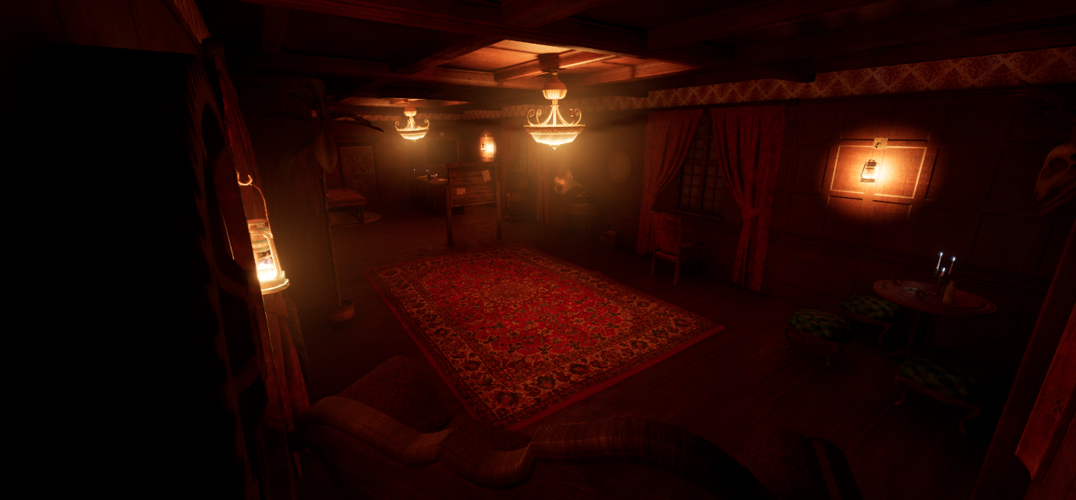
Figure 1: The Reception Carriage of the train, displaying luxurious decorations inspired by steampunk, Victorian, and Western aesthetics.
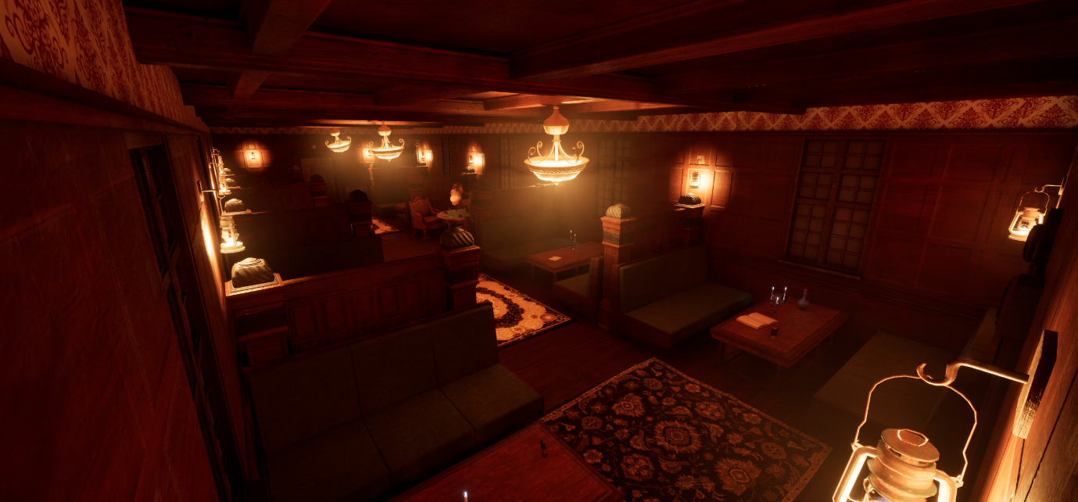
Figure 2: The Seating Carriage of the train, further displaying more luxurious interior design inspired by steampunk, Victorian, and Western themes.
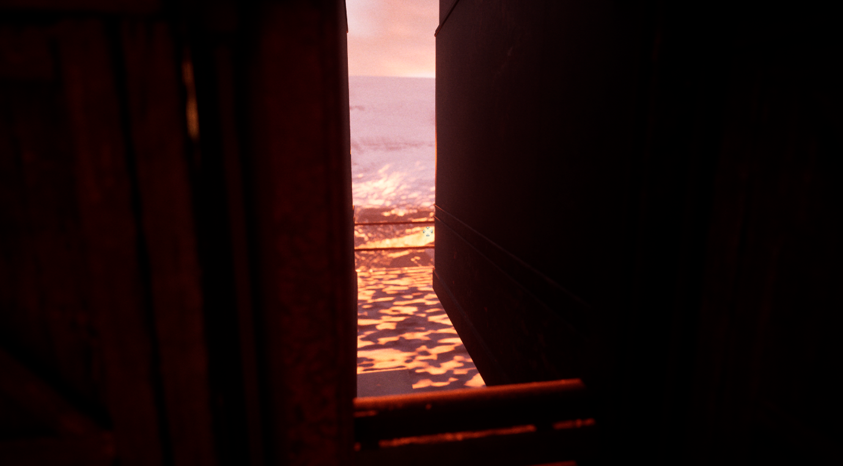
Figure 3: A small section of exterior space between two train carriages, showcasing the outside mountain range and train tracks.

Characters
Thaddeus Mercer (Protagonist)
A 27-year-old police detective on his way home to Spencer, North Carolina onboard The Old Royal Express Line steam train. Observant, smart, and analytical, Mercer uses his skills as a detective to piece together clues using the Investigation Menu to complete puzzles within the game. Equipped with a police standard flashlight.

Mammonach the Demon (Antagonist)
A once greedy and selfish man named Marcellus Mayweather who owned The Old Royal Express Line, Mammonach was born from Marcellus’ greed. The malevolent force driving the possession of the train, the culprit of the train’s crash 20 years prior, and the end goal for players to defeat.
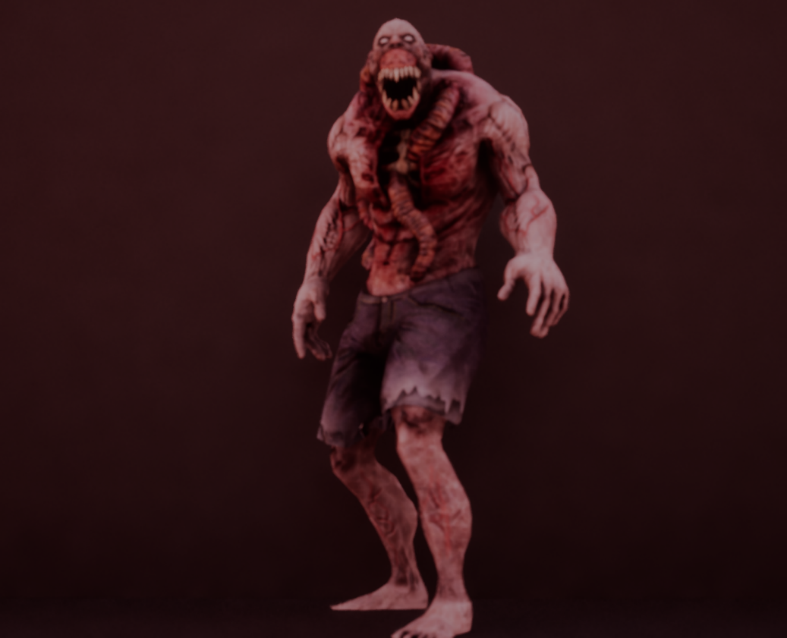
Figure 4: Mammonach the Demon, from the player death cutscene.
Ghosts (Side Characters)
The victims of the fatal crash from 20 years ago, bound to ride the train for eternity. Each with unique quirks and histories, they offer quests, clues, information, and time bonuses that shape the journey. Each ghost reflects a fragment of the train’s past, from a duty-bound conductor to a scheming gambler to a bellboy forever tidying luggage.
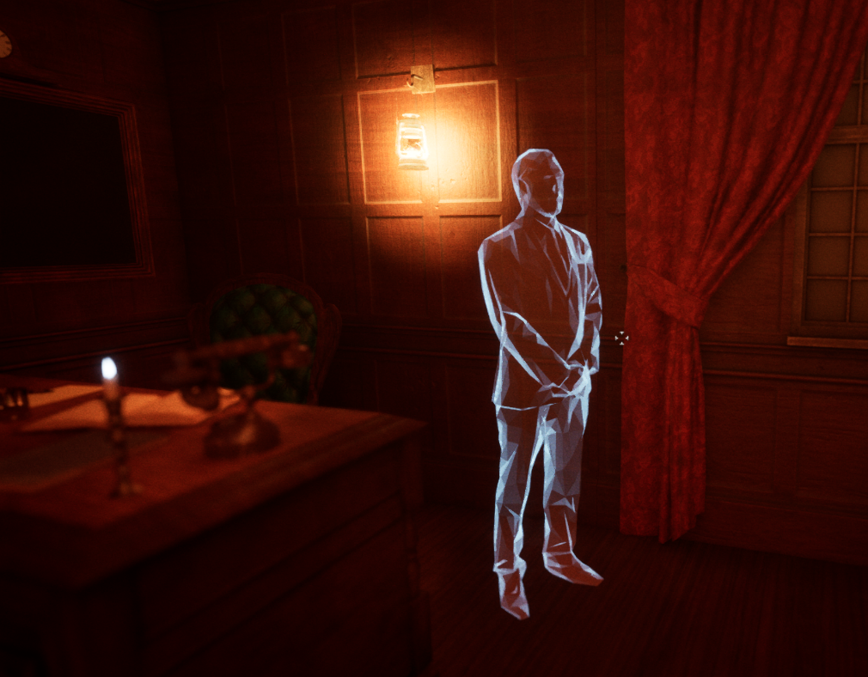
Figure 5: One of the ghosts of the train.
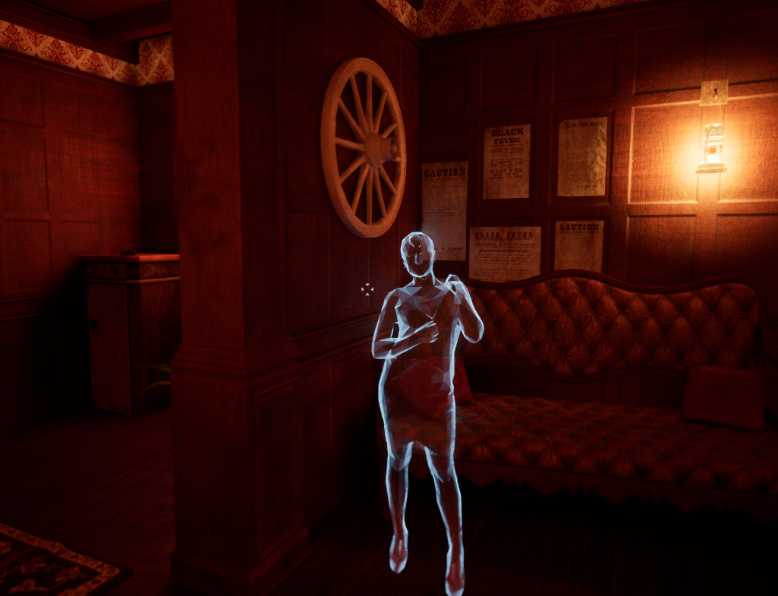
Figure 6: Another ghost of the train.
The Watcher (Narrative Character)
A mysterious figure influencing events from the shadows. Never directly encountered, but ever-present through collectibles and narrative breadcrumbs.

Narrative Flow
The story unfolds through ghost interactions and collectibles, allowing players to uncover as much – or as little – of the story as they choose. This supports both minimal and lore-rich playthroughs alike, encouraging exploration without forcing exposition.

Gameplay Overview

Core Mechanics
The games’ small environment empathizes exploration and puzzle solving over advanced mechanics. Players use four primary controls:
- Movement: To traverse the level.
- Interacting: To interact with interactable items and characters.
- Flashlight Toggle: To turn the flashlight on and off.
- Pause: To pause the game and showcase the Pause Menu.

Objectives
The main objective is to reach the Controls Carriage to stop the train before the timer runs out. Players are given 30 minutes post-tutorial to accomplish this, which can alter through ghost interactions.
To advance to the Controls Carriage, players must solve the other carriage’s puzzles in order to find the key to advance. These puzzles act as the side objectives of the game and are mandatory for completion. Ghost interactions and collectibles are not mandatory but can offer important information to the whereabouts of these keys.

Rules & Systems
The game features a timer system inspired by real-life escape rooms which counts down as soon as the tutorial is completed at the beginning of the game. The timer can be increased or decreased through ghost interactions, and if the timer runs out, players can either restart from their latest autosave or quit to the Main Menu.
Each carriage contains an autosave checkpoint at its entrance which can be used for resetting the game following the timer running out, or upon death. Players can also manually trigger a reset through the Pause Menu if they wish.

Progression
Progression gradually ramps up both horror and narrative intensity. Earlier carriages feature lighter scares and surface-level story developments, while later ones deliver heavier reveals and scarier horror experiences. This will help keep players engaged by making them earn a more challenging, scary, yet story-rewarding experience the more they advance.
The demon encounters will be scripted for specific moments and will appear more as players advance further. This allows players to gain familiarity with the game’s controls and how to combat the demon, while also feeling natural to the story (where the demon would appear more often as players get closer to completing their goal).

Level Design

Level Layout
The level will be split into six separate carriages, each representing a unique theme and puzzle designed to its function. These are: Reception Carriage, Bar Carriage, Dining Carriage, Seating Carriage, Storage Carriage, and Controls Carriage.
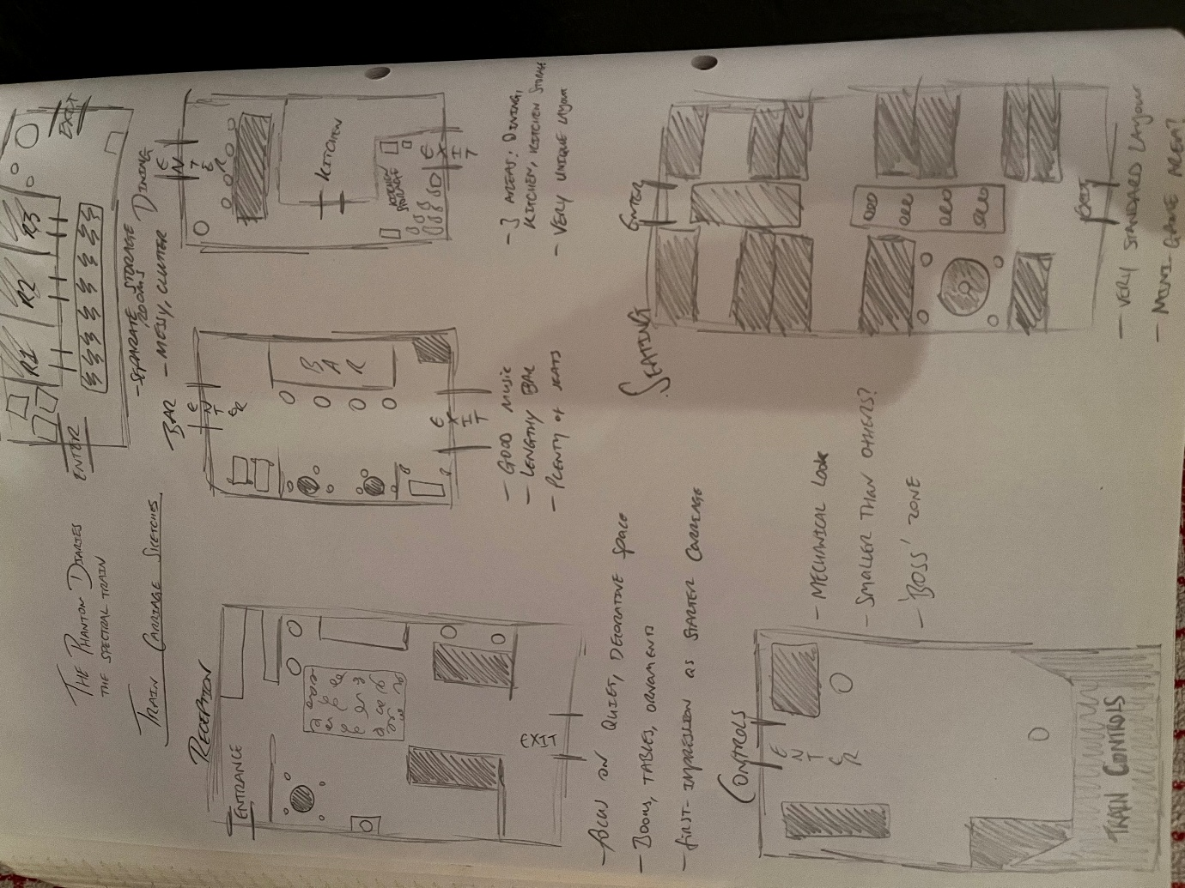
To keep the game looking and feeling fresh – and to prevent repetitive experiences – each carriage has a distinct visual identity, with its design and furnishings reflecting its function. Each carriage contains a unique puzzle for players to solve to find the key for the next carriage. These puzzles match the function of the carriage they are in.
Figure 7: My sketches for each carriage layout during the game's pre-production phase.

Challenges & Puzzles
Demon encounters serve as quick-time events where the player must shine their flashlight at the demon before they are attacked; failure results in death and reset. Additionally, each carriage features its own function-themed puzzle to match the carriage setting, as previously mentioned.
Carriage | Puzzle Type | Mechanic | Theme
Reception Carriage | Key in book on specific page number | Search collectibles for specific page number | Reading
Bar Carriage | Key in 3-digit-lock chest | Clue puzzle related to alcoholic drinks from the Bar | Drinks
Dining Carriage | Key in 3-digit-lock chest | Observation puzzle related to meals from a menu | Food
Seating Carriage | Mini game | Liar’s Dice mini game versus a ghost | Ghost interaction
Storage Carriage | Hidden in plain sight | Environmental exploration | Trick/false puzzle
Controls Carriage/Finale | Multi-carriage runback sequence | Multiple demon encounters | Climax/final battle

Rewards & Progression
The game aims to deliver a smooth, steady progression of rewards by slowly but surely increasing the frequency of scares and demon encounters and producing more flashlight batteries and deeper story revelations the further players advance. The difficulty will escalate both narratively and mechanically, rewarding persistence.

Art & Visuals

Art Direction
The game uses a realistic art direction to maximize immersion and elevate the horror atmosphere through believable environments and lighting, a method used by popular horror game franchises such as Outlast and Resident Evil, which both served as inspirations for this game’s art direction.

Characters & Environment
The player character does not have a body of their own as – like with most first-person games – it is not the most important aspect. The demon is represented by a realistic monster design that seamlessly fits into the world. The ghosts are represented by semi-transparent, blue-tinted models with minimal facial detail.
The environment is a high-fidelity interior of a classy and luxurious steam train with era-authentic furnishings and strict personality designs for each carriage to match their function.
The outside area surrounding the train features looping mountain scenery to match the setting of the game, with train tracks underneath to further increase immersion.

HUD & UI Elements
The HUD is minimal in design, showcasing only essential elements to keep the experience fully immersive, such as:
- Aiming Cursor (Centre): Helps players aim their interaction line to wherever they want.
- Interaction Prompt (Bottom-Centre): Displays prompts for players to interact with interactable objects and characters.
- Notification Pop-Up (Top-Left): Showcases important notifications such as autosaves, locked doors and chests, or when the player cannot use a flashlight battery due to having full capacity.
- Flashlight Battery Indicator (Bottom-Left): Reveals a flashlight icon to the player whenever their flashlight is on, as well as a countdown timer of the current battery value for players to keep track of.
The Main Menu appears transparent over the background of the game’s opening cutscene, creating a seamless transition between menu and gameplay, featuring:
- Game Title: Big and bold.
- Play and Load Buttons: For starting a new game or loading a game from save.
- Options Button: For viewing the controls scheme or editing a variety of options, such as resolution, audio volume, and brightness.
- Quit Button: For quitting the game.
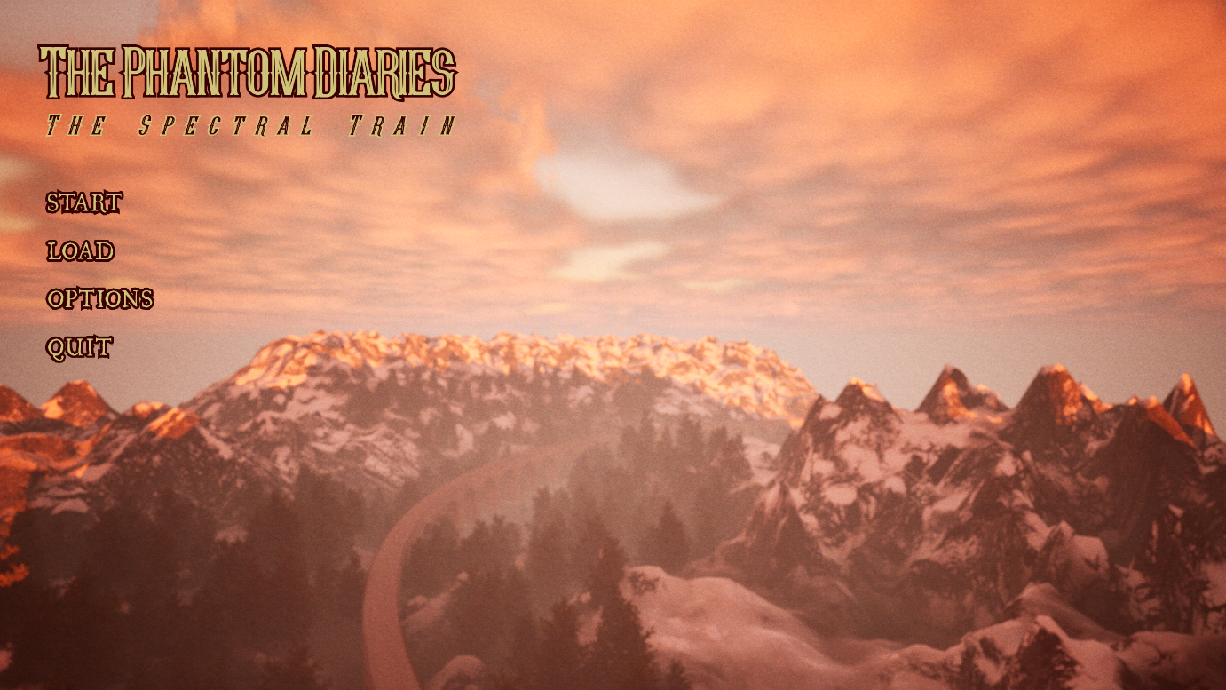
Figure 8: The Main Menu.
The Pause Menu overlays most of the game screen with a canvas in the middle to display information and buttons on the side of the canvas for switching between the menu elements:
- Home Page: Displays the game title, the current carriage the player is in, and the remaining game time.
- Inventory Page: Displays all the collected items of the player.
- Investigation Page: Can only be entered by clicking on a Clue Item from the Inventory Page. Showcases the currently selected clue and any other related clues.
- Information Page: Can only be entered by clicking on a Lore Item from the Inventory Page. Showcases the detailed information of the item.
- Options Page: Same function as the Main Menu.
- Reload Button: Reloads the game from the player’s latest autosave.
- Quit Button: Quits to the Main Menu.
The HUD and menus use Western-looking, early 20th century fonts with a burgundy and cream-yellow colour scheme to match the train’s identity and the setting of the game. Authentic handwritten and accessibility typewriter fonts enhance immersion within the Investigation and Information Pages when reading item information and clues.
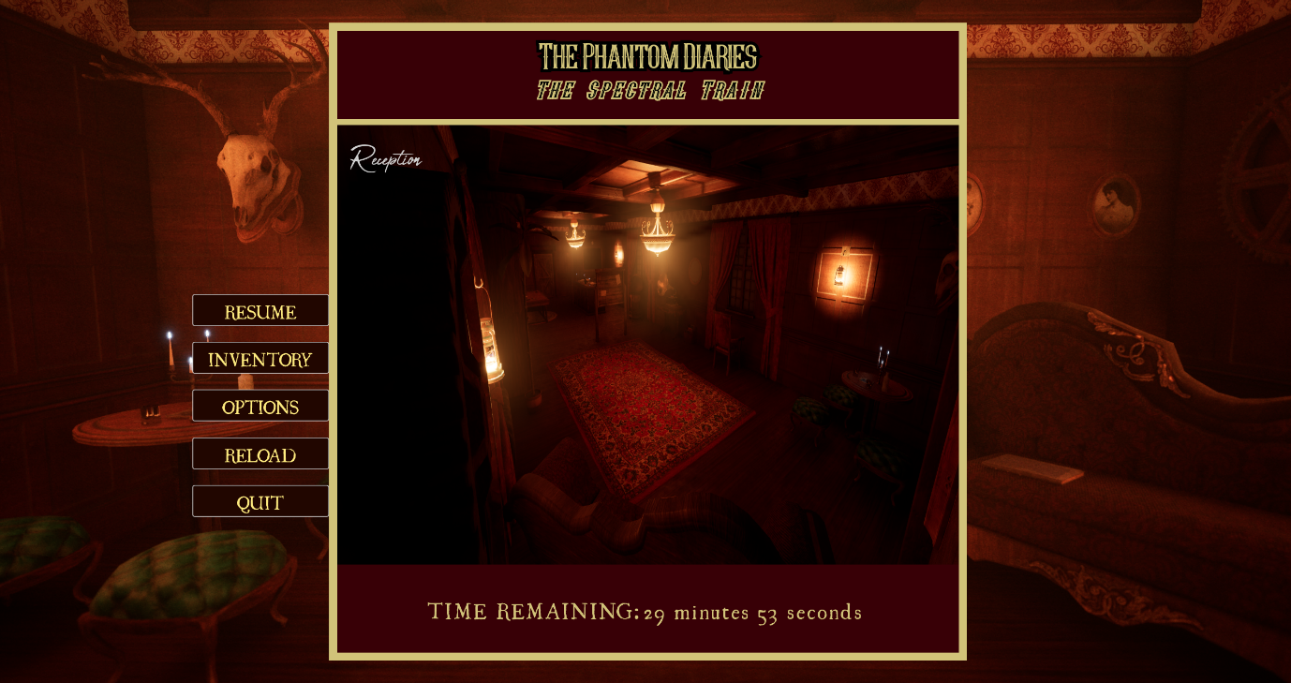
Figure 9: The in-game Pause Menu.
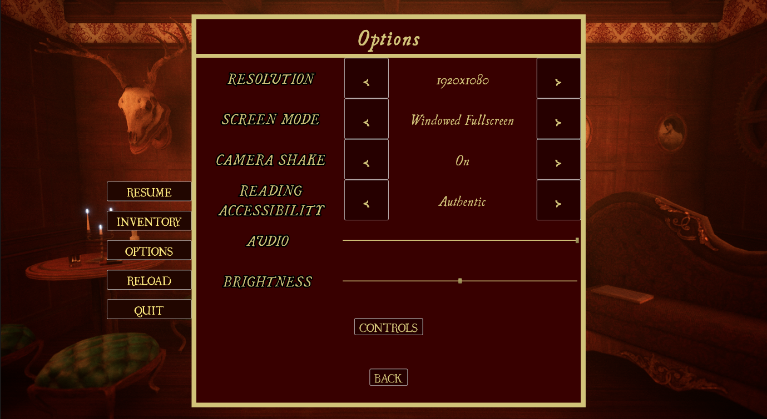
Figure 10: The Options Menu, accessible from the Pause Menu.
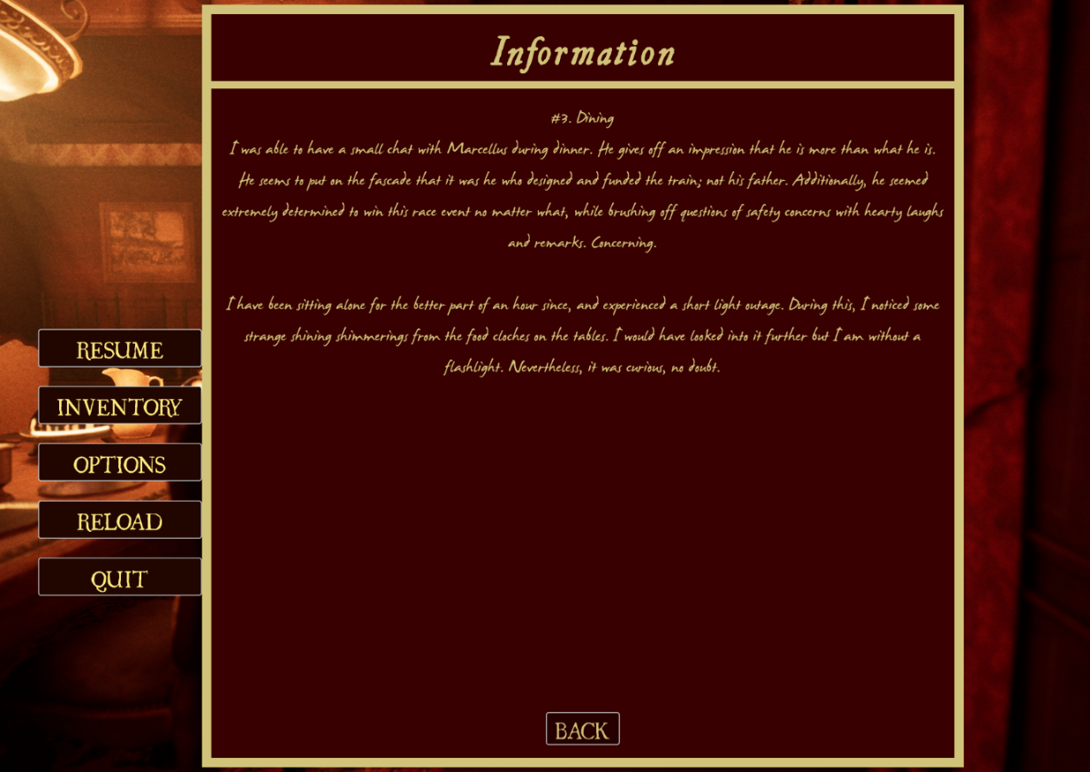
Figure 11: The authentic font of the game for items with readable information.
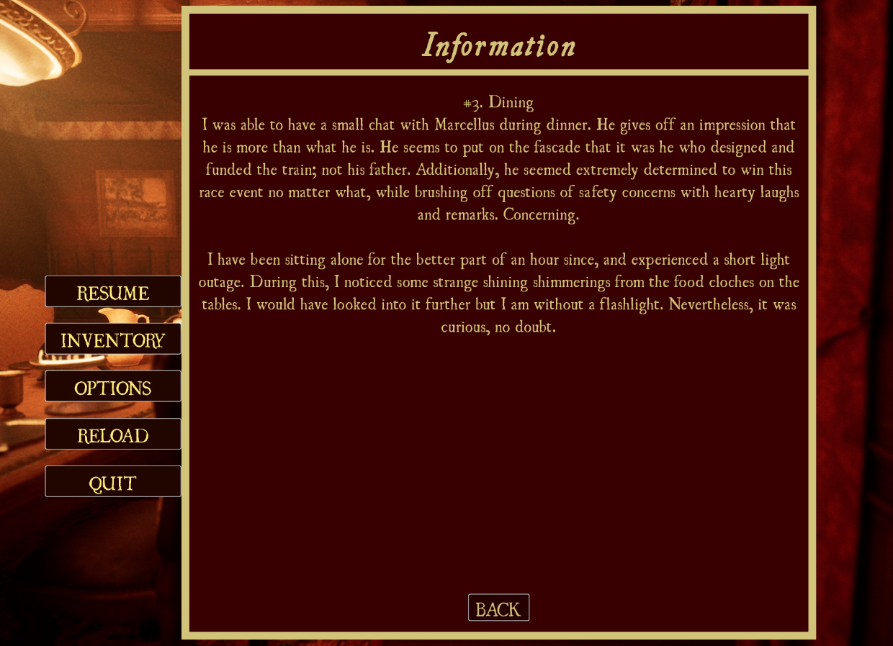
Figure 12: The accessibility font for easier reading.

Animations
Player
The player uses a camera shake for idle and walking movements to simulate first-person animations but does not have any body animations due to not having a body model.
Demon
The demon has screaming and chasing animations that are used for its mechanics where, after spawning, the demon screams before chasing the player to offer a small reaction buffer to the scenario.
Ghosts
The ghosts remain fixed in place throughout the game, but their bodies animate with a glow effect to showcase their ghostly nature.
Environment
Environmental objects such as lights, chandeliers, doors, books, and chests feature dynamic animations to bring the world to life, while the exterior mountains and train tracks animate to simulate the movement of the train.
Cinematics
The game includes opening and ending cutscenes to tell the story, along with dedicated sequences for death and timer expiration.

Audio

Music
Authentic 1920’s phonograph music is used from source-free libraries to further the immersion of the experience. Having these play from phonographs dotted throughout the level not only helps build atmosphere but solidifies the setting of the game. Furthermore, era-specific ambient score, such as guitar and violin pieces, is employed for cutscenes and menus to build a cozy yet tense mood.
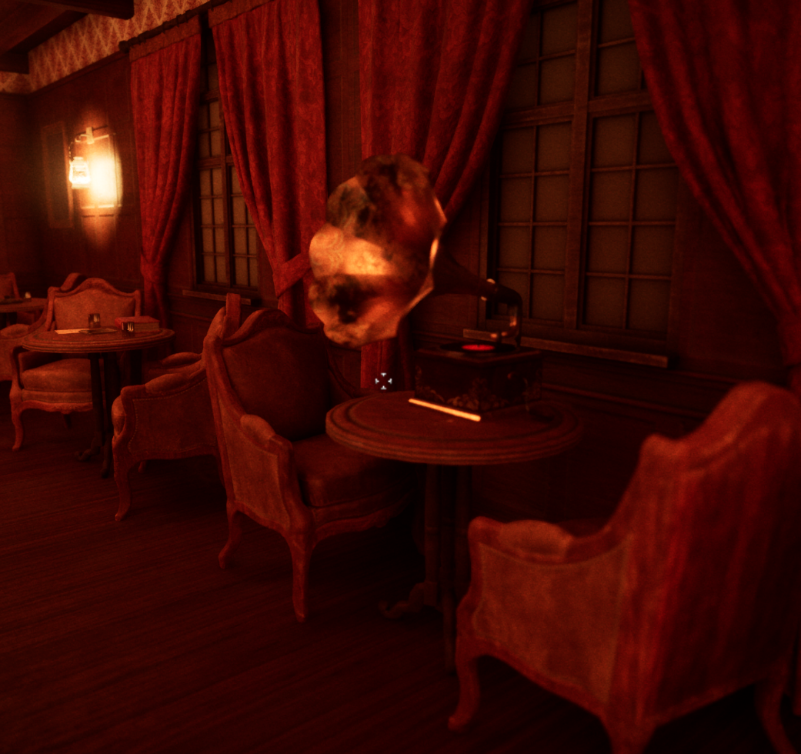
Figure 13: A phonograph from the game, which plays music.

Sound Effects
Interactions within the game use context-sensitive sound effects, such as squeaks for doors and chests, paper rustles for books and pamphlets, lock shakes for locked containers, flicks for light switches, key jangles for keys, and more.
Thematic notification tones are used to fit the music style and to alert players to any incoming notifications. The demon utilizes horrifyingly distinct spawn and chase cues to help the player gain familiarity with its spawning and mechanics.
Finally, appropriate and professional UI sounds, such as button clicks, are used for the menus to create a fully-fledged and enjoyable user experience.
All sound effects used were carefully chosen to match the time period of the game.

Controls & User Interface

Controls
- Movement (WASD): Allows the player to traverse the game world.
- Interacting (E): Allows the player to interact with collectibles, in-game moveable objects such as doors and chests, and ghosts.
- Flashlight Toggle (Q): Allows the player to illuminate dark areas and combat the demon.
- Pause/Menu (Esc): Allows the player to pause the game, displaying the Pause Menu.
A key rebinding system was not created due to the small and intuitive controls set, along with no requests for this system following testing feedback.

UI Flow
To maximize immersion and limit unnecessary information, the HUD displays only four elements at any given time. The Inventory, Investigation, and Information Pages within the Pause Menu provide detailed and immersive interfaces for exploring collectibles in more detail. Both the Main and Pause Menus feature clear and intuitive layouts with essential functionality for a smooth experience. All menus and HUD elements share a consistent colour palette and theme, ensuring visual synchronization. Menus support full mouse navigation for ease-of-use.

Technical Specifications

Engine & Tools
The Phantom Diaries: The Spectral Train was developed with Unreal Engine 5.4, with C++ for core systems and Blueprints for supporting features. Rider (coding), GIMP (decal editing), and Audacity (audio) was used for other purposes.

Platform Requirements
Minimum Requirements:
- OS: Windows 10 64-bit
- Processor: AMD Ryzen 5 2600 / Intel Core i5-9400F
- Memory: 8 GB RAM
- Graphics: NVIDIA GeForce GTX 1060 / AMD Radeon RX 580
- VRAM: 4 GB
- Storage: 5 GB available space
- DirectX: Version 12
Recommended Requirements:
- OS: Windows 10/11 64-bit
- Processor: AMD Ryzen 5 5600 / Intel Core i5-12400
- Memory: 16 GB RAM
- Graphics: NVIDIA GeForce RTX 2060 / AMD Radeon RX 6600
- VRAM: 6 GB
- Storage: SSD with 8 GB available space
- DirectX: Version 12

Performance Targets
- Frame Rate: 60 FPS at 1080p on Minimum Specs, 120 FPS at 1080p on Recommended Specs
- Resolution: 1920x1080, supports multiple resolution options
- Loading Times: ~1-2 seconds on SSD; ~5-10 seconds on HDD
- Quality Presets: Locked at Epic to ensure consistent presentation. Players may adjust Resolution to improve performance

Development & Testing Hardware

Primary Development Machine
- OS: Windows 11 64-bit
- Processor: AMD Ryzen 7 7800X3D
- Memory: 32 GB RAM
- Graphics: NVIDIA GeForce RTX 4070 SUPER
- VRAM: 12 GB
- DirectX: Version 12

Quality Assurance Testing
The game underwent testing across multiple mid-high range PCs, including SSD and HDD configurations. All tests achieved stable 60+ FPS at 1080p. The game went through a variety of updates and tweaks following player feedback before the release build.

Postmortem
What Went Well
- The game showcases all aspects of the original intended design, truly allowing the project to shine in all the imagined areas (horror elements, deep story, intricate world design, puzzle mechanics, and more).
- Playtesting received positive reviews in relation to the imagined areas, confirming the success of the game design.
- The game has been optimized to smooth and enjoyable levels for an excellent user experience.
- Production of the game taught and enhanced many new coding and Unreal Engine development techniques that can be applied to later projects.
What Could Have Been Better
- Different versions of the game (Alpha, Beta, Pre-Release, Gold) could have had testing implemented for an easier bug-fixing and gameplay-changing experience. The game was only tested in the Pre-Release version, meaning almost all systems were implemented, removing the ability to completely remake a mechanic or system depending on feedback. Some puzzles were revealed to be harder than others and needed more clarity. If tested and found in an Alpha or Beta version, changes to these puzzles would have been easier.
- Earlier stages of development relied on messy, unkempt notes. Maintaining consistent documentation throughout the entire development process would have allowed for easier production and would have streamlined later design referencing and task management.
Key Lessons Learned
- Creating and maintaining a small scope is crucial for the completion of video games, especially when developed solo. Many ideas had to be cut to keep the scope of the project at a realistic size to ensure the development could be completed, and within a respectable time range.
- Extensive and vigorous quality assurance testing across all stages of development is critical for the overall finished product, ensuring all bugs – both minor and major – are discovered and fixed to create a professional final version of the game.
- Ensuring all gameplay systems and mechanics are implemented and working as expected before implementing the world itself is a smart and time saving manoeuvre that helps maintain motivation and allows realistic goals to be set and completed.
- Following an intricately detailed game development plan using notes and more professional tools, such as Trello, allows for the creation of a proper and easy-to-follow design system which helps keep track of complete and incomplete tasks.

Future Plans
The Phantom Diaries: The Spectral Train is a self-contained experience with no plans for any downloadable content. However, many mechanics and storylines were cut during scope refinement. These concepts – along with a multitude of new ideas – may form the basis of a future sequel with expanded gameplay and narrative depth.
Additionally, research into releasing the game on the web may be conducted to gain some experience with releasing games officially while also trying to gain attraction for the product.

References & Inspirations
Historical
The real-world event ‘The Wreck of the Old ‘97’ served as a loose inspiration behind the story and a strong inspiration behind the setting of the game, utilizing the same time period, locations, and events as the historical occurrence.
Games
Classic horror game franchises such as Outlast and Resident Evil served as loose inspiration for the world building and horror elements of the game to create the scariest experience possible.
Other
The general life activity of escape rooms serves as a massive inspiration for the gameplay of the game. My college project some years ago also serves as the main inspiration, which brought these ideas to light in a very small, less attuned manner that stuck with me for many years until this project was created.

